AN ARTIFICIAL INTELLIGENT WEATHER FORECASTING SYSTEM BASED ON A HYBRID NEURAL NETWORK
JASMEEN GILL
Department of Computer Science, RIMT-IET, Mandi Gobindgarh, Punjab, India
E-mail: er.jasmeengill@gmail.com
SHAMINDER SINGH
Department of Computer Science, GGI, Khanna, Punjab, India
E-mail: er_shaminder@yahoo.co.in
PANKAJ BHAMBRI
Department of Information Technology, GNDEC, Ludhiana, Punjab, India
E-mail:pkbhambri@gmail.com
Weather plays a significant role in terms of life, property, agriculture and industry. Neural networks are capable of predicting the non-linear behavior of weather without the physics being explicitly explored. The most common method to train neural networks is through gradient decent based back propagation algorithm. This paper investigates the problems incurred while training neural network through back propagation and utilizes it to develop an artificial intelligent weather forecasting system based on hybrid approach using genetic algorithms. The results are very encouraging and it is found that the hybrid weather forecasting model can make predictions with high degree of accuracy.
Keywords: neural networks, weather forecasting, back propagation algorithm, genetic algorithm, and hybrid model.

Introduction
Weather forecasting means to predict the future atmospheric conditions for a particular time and location based on the past as well as present trends. Weather forecasting is significant firstly, in terms of protecting life and property through weather warnings. Secondly, forecasts based on temperature and precipitation, are important to agriculture, and are used by utility companies to estimate demand over coming days. Scientific weather forecasting relies on empirical and statistical techniques, such as measurements of meteorological parameters and computer-controlled mathematical models. At micro level, it is impossible to definitively predict the state of the atmosphere using empirical approach, owing to the chaotic nature of the fluid dynamics equations involved. Furthermore, existing observation networks have limited spatial and temporal resolution, especially over large bodies of water, which introduces uncertainty into the true initial state of the atmosphere. At macro level, weather forecasting is usually done using the data gathered by remote sensing satellites which are inherently costlier systems, also require complete support system and are capable of providing information generalized over a larger geographical area.¹ The variables defining weather conditions like temperature, relative humidity, rainfall etc., vary continuously with time, which required the development of a forecasting model capable of extracting the relationship between the inputs and outputs of a process, without the physics being explicitly provided. This diverted the attention of researchers towards the field of artificial neural networks.
Artificial neural networks are suitable for solving non-linear problems that are difficult to be solved by the traditional techniques. It is an innovative approach to construct computationally intelligent systems that are supposed to possess human-like expertise with in a specific domain, adapt themselves and learn to do better in changing environments, and provide reasoning about their decisions.² Hence a new era began with the advent of neural networks in the field of weather forecasting.
The major reasons of using artificial neural networks in the field of weather forecasting are: they would reduce the computational power required to accurately predict atmospheric variables from a supercomputer to a single neural network, a large database is available of historical weather data which can be used as training sets, they find the best generalized network to solve patterns outside their training sets, they can detect and utilize hidden patterns in data to arrive at a solution, and finally, they have been shown to accurately predict irregular and complex variables in past work.³
Neural networks learn by example i.e. they can be trained with known examples. One of the most popular training algorithms in the domain of neural networks used so far, for weather forecasting is the gradient descent based back propagation algorithm. The algorithm suffers from several problems and attempts have been made by researchers to solve these problems using hybrid systems which along with eliminating the drawbacks of the algorithm, provides the true benefits in training the network.^{4, 5} But, in the field of weather forecasting, such efforts are still to be put up.
So, the present research aims at developing an artificial intelligent weather forecasting model based on hybrid neural networks approach and to compare the effects of training the network through the gradient based back propagation technique and the hybrid technique.
The remainder of the article is organized as follows. A brief description of the algorithms under analysis is provided in Section 2 and 3. The details of the hybrid technique for weather forecasting model are shown in Section 4, followed by results in Section 5. Finally, the conclusions are summarized in Section 6.

Back Propagation Algorithm
Back propagation is a form of supervised learning for multi-layer nets, also known as the generalized-delta rule. It is a gradient descent method in which gradient of the error is calculated with respect to the weights for a given input by propagating the error data at the output layer backwards to earlier ones, allowing incoming weights to these layers to be updated. So, the combination of weights which minimizes the error function is considered to be a solution of the problem. The back propagation algorithm is an evolved mathematical tool; however, execution of the training equations is based on iterative processes, and thus is easily implemented on a computer.⁶
Although widely used, the back propagation algorithm has not escaped criticism. The method of backwards-calculating weights does not seem to be biologically plausible; neurons do not seem to work backward to adjust the efficacy of their synaptic weights. Thus, the back propagation-learning algorithm is not viewed by many as a learning process that emulates the biological world but as a method to design a network with learning. Back propagation algorithm works well on simple training problems. However, as the problem complexity increases, the performance of back propagation falls off rapidly because gradient search techniques tend to get trapped at local minima. When the nearly global minima are well hidden among the local minima, back propagation can end up bouncing between local minima.⁷
The algorithm suffers from extensive calculations and, slows training speed. In large networks, increasing the number of training patterns causes the learning time to increase faster than the network. The computational speed inefficiency of this algorithm has triggered an effort to explore techniques that accelerated the learning time by at least a factor of 2.⁸
Also the convergence of the algorithm is very sensitive to the initial value and it often converges to an inferior solution and gets trapped in a long training time. Despite its wide applicability, the gradient based back propagation algorithm cannot be applied to all neural network systems which can be imagined. In particular, the algorithm requires that the activation functions of each of the neurons in the network be both continuous and differentiable.⁸
Hence there is an immense need of a hybrid technique which when integrates with the back propagation algorithm serves the purpose of training the network. One such candidate is genetic algorithms, the computerized search and optimization algorithms that mimic the principle of natural genetics and natural selection.⁹

Genetic Algorithm
Genetic Algorithms are adaptive heuristic search algorithm premised on the evolutionary ideas of natural selection and genetic. These are used to simulate processes in natural system necessary for evolution based on Darwinian Theory of survival of the fittest. Genetic Algorithms perform directed random searches through a given set of alternatives to find the best alternative with respect to given criteria.⁹
An initial population of chromosomes (set of strings) is taken to generate offspring (from fit parents) that competes for survival to make up the next generation of population. One of the genetic features is that instead of focusing on one point of the search space of a chromosome, it works on a population of chromosomes. The goodness or badness of the answer is determined by the value returned by the goal function. The more suitable the answer is it has a bigger fitness. Therefore the fittest chromosome takes part to produce offspring with more probability.⁷
GA encompasses three main operators: selection, crossover and mutation. Selection operator searches according to the fitness of the members based on fitness values and the members of the population with better fitness can participate several times while the members with worse fitness may be deleted in order to obtain a larger fitness average. Crossover operation allows an exchange of the design characteristics between two mating parents. Mutation operation prevents losing unexpected valuable genetic information in the population during selection and crossover operation.⁹
Not only does genetic algorithm provide an alternative method to solving problem, it consistently outperforms other traditional methods in most of the problems. Genetic algorithm is a parallel stochastic optimizing algorithm and is good at global searching (not in one direction). Also it works with a population of points instead of a single point. ¹⁰ Secondly, genetic algorithms work with a string coding of variables instead of the variables. The advantage of working with a coding of variables is that coding makes the search space discrete even though the function may be continuous. Thus, a discrete function can be handled with no extra cost. Also genetic algorithm can be applied to a wide variety of problems. We always get the solution & the solution gets better with time.⁷

Modeling Setup
In this section, the features of back propagation algorithm and genetic algorithms are integrated. The proposed weather forecasting model based on hybrid technique starts with the collection of weather related data, selection of weather parameters to be forecasted, normalization of data, feature extraction, formation of training data set (containing inputs and outputs) and testing data set (containing inputs). Finally the methodology and its simulation have been done.

Collection of data
The data used in this research are the daily weather data for the Ludhiana city of Punjab (India). The data in the un-normalized form have been collected from the “Meteorological Department of Punjab Agriculture University, Ludhiana (Punjab)” of the year 2009. The first thirty days data (month of January, 2009) have been used in this research. For training, the first twenty five days data have been used and next five days data have been used for testing purposes.

Selection of input variables
The daily weather parameters collected are shown in table 1 along with their units of measurement. The parameters chosen in this setup for the prediction are mean air temperature (ºC), relative humidity (%) and daily rainfall (mm). There is no particular reason behind this choice. The choice is made just to predict three main weather variables.

Table 1. Weather parameters
Sr. No. | Meteorological Variables | Unit
1. | Air Temperature | ºC
2. | Soil Temperature | ºC
3. | Relative Humidity | %
4. | Vapor Pressure | mm
5. | Wind Speed | Km/h
6. | Wind Direction | ---
7. | Sunshine | hrs
8. | Rainfall | mm
9. | Evaporation | mm

Data preprocessing
After the collection of data and selection of the weather parameters, next issue is the normalization of data. Neural networks generally provide improved performance with normalized data. The use of original data to network may cause convergence problem. All the weather data sets were, therefore, transformed into values between 0 and 1 by dividing the difference of actual and minimum values by the difference of maximum and minimum values.⁴
At the end of the algorithm, the outputs are de-normalized into the original data format for achieving the desired result.

Feature extraction
In certain cases, the weather parameter to be forecast can be estimated based on the features obtained from the past data of same parameter. However, in some cases the parameter to be forecast exhibits a strong dependence on other weather parameters also. In such cases the input to the network should include the features extracted from other weather parameters also.
As some information is needed to access whether a specific feature is suitable for the model or not for inclusion in input data set, the selection of the features is made by correlating these features with the parameter to be estimated. The statistical indicators, which can be used as input features for the model¹, are as follows:
(i) Day Number: It is fed to the network as first input to keep track of the day for which the network is to be trained.
(ii) Moving Average (MA): It is calculated progressively as an average of N number data values over the certain period. For a data set is represented by dt, dt-1, dt-2 ,…, d0, where dt is present and d0 is the first data value, the moving average with a sliding window of period N is
MA = (dt + dt-1 + dt-2 +………..+ d0)/ N
(iii) Oscillator (OSC): Oscillator is used to indicate the rising or trailing trend present in the time series.
OSC = MAN1-MAN2
where N1 and N2 are different periods and N1>N2.
(iv) Rate of Change (ROC): It indicates the rate of change of the variable at present, as compared to the value of the variable at certain period back. Thus percentage ROC at ‘a’ times back is given by,
ROC = (1-dt/dt-a) × 100
(v) Moments: The rth moment of X, μr is given by
μr = (Σ(X − Xmean )r )/N
where X is total data set and Xmean is the mean of N data variables.

Methodology
An initial population will be randomly generated constituting the chromosomes. The representation of chromosomes varies according to the problem. In the present system, chromosomes represent the set of weights. After the formation of initial population, the weights will be extracted from each chromosome depending upon the number of genes a chromosome has. With this weight set, the network will be trained for the first cycle and the cumulative error will be calculated over the inputs obtained (features extracted) from the weather data.
The fitness function will be evaluated by reciprocating the cumulative error value. More is the fitness value; more are the chances of a chromosome to be selected for reproducing an offspring. With this criterion in mind, mating pool will be prepared by replacing the individual with minimum fitness value with the individual having maximum fitness value. Then the crossover operator will be applied for preparing the new population. Afterwards, if required, mutation is applied over the individuals to maintain the diversity of the population. This process will be repeated till the stopping condition is reached.^{5, 7}

Population Generation
Weight Extraction
Error & Fitness Calculation
Testing (Solution)
Crossover
Mutation
Selection
New Population

Figure 1: Methodology for integrated BP/GA technique

The various steps of weather forecasting model based on BP/GA algorithm are explained below:
(i) Start: Generate random population of ‘p’ chromosomes (suitable solutions for the problem).
Extraction: Extract weights for input-hidden-output (l-m-n) layers from each chromosome x.
(ii) Fitness: Evaluate the fitness f(x) of each chromosome x in the population by reciprocating the cumulative error values obtained for each input set (weather forecasting data).
(iii) New population: Create a new population by repeating following steps until the new population is complete.
- Selection: Select two parent chromosomes from a population according to their fitness (the better fitness, the bigger chance to be selected)
- Crossover: Cross over the parents to form new offspring (children). If no crossover was performed, offspring is the exact copy of parents.
- Mutation: With a mutation probability mutate new offspring at each position in chromosome.
- Acceptance: Place the new offspring in the new population.
(iv) Repeat: Repeat steps 3 to 5 until stopping condition is met.
(v) Test: Return the best solution in current population using the test set inputs (weather forecasting data) and the weights (obtained in the above five steps).

Simulation
The proposed model uses Multilayer Feed forward architecture that has one or more than one hidden layers (layers between input layer and output layer), whose computation nodes are hidden neurons also termed as hidden units. The configuration of the neural networks depends highly on the problem. Therefore, it is left with the designer to choose an appropriate number of hidden layers and hidden-layer-nodes based on his/her experience. Thus, an appropriate architecture is required for each application using the trial and error method. The features extracted from weather data are applied as input samples and the target is taken as the parameter to be estimated during training operation.
In this research, 5-3-1 neural network architecture has been used for BP/GA technique. The number of input neurons is 5 representing the date fields and input feature to be forecasted, the number of hidden neurons is 3 for processing and the number of outputs is 1 representing the weather variable (amongst mean air temperature, relative humidity and rainfall) to be forecasted. A real coding system has been adopted for coding the chromosomes.
As the network configuration is 5-3-1, therefore, the numbers of weights (genes) to be determined are (5+1)*3 = 18. Taking the gene length as 5, the string representing the chromosomes of weights will have a length of 18*5 = 90. This is the weight matrix of the input-hidden-output layers. For cross over, we have used a two-point cross over selected at random and the selection is made on the basis of fitness value. The network is considered to be trained when 95% [7] (raj) of the individuals have same fitness value. After the training phase, testing is done with the set of weights obtained during the training phase. In the testing phase, the inputs are fed to the network along with the final weights and we obtain the outputs thereafter.

Results and Analysis

Calculation of Population Size
The first step in the proposed technique is initializing the population. The size of population depends upon the network architecture and the length of a gene. Below are given the network architecture and their corresponding population size in table 2.

Table 2. Calculation of population size
Network Architecture | No. of weights | Length of chromosomes | Population  Size
5-1-1 | (5+1)*1 | 6*5 | 30
5-2-1 | (5+1)*2 | 12*5 | 60
5-3-1 | (5+1)*3 | 18*5 | 90
5-4-1 | (5+1)*4 | 24*5 | 120
5-5-1 | (5+1)*5 | 30*5 | 150

Selection of Hidden Neurons
As per discussion in the present work section, the major issues regarding neural network architecture is the selection of number of hidden neurons in the hidden layer. So a comparison for MAPE values has been done corresponding to different number of hidden neurons along with the population size and number of iterations in which the network can be sufficiently trained with minimum error value.
Here the BP/GA technique has been implemented by taking different population size. For each value of population, the program has been executed and the error has been calculated. Table 3 shows the variations in population size, number of neurons in hidden layer and the corresponding mean absolute percentage error values for the integrated BP/GA technique.

Table 3. MAPE values for population sizes
Population  Size | Hidden  Neurons | No. of Iterations | MAPE  Value
30 | 1 | 110 | 1.10
60 | 2 | 140 | 0.86
90 | 3 | 220 | 0.42
120 | 4 | 282 | 1.47
150 | 5 | 425 | 1.85

From the table 2, it is clear that the MAPE value is the lowest corresponding to population size 90 and number of hidden neurons as 3. So the present setup will use this population size for further research. Our main motive is to select that population size or number of hidden neurons for research which lays stress over the principle of minimum error value.

Error vs. Iterations
The proposed model uses Multilayer Feed forward architecture that has one or more than one hidden layers (layers between input layer and output layer), whose computation nodes are hidden neurons also termed as hidden units. The configuration of the neural networks depends highly on the problem. Therefore, it is left with the designer to choose an appropriate number of hidden layers and hidden-layer-nodes based on his/her experience. Thus, an appropriate architecture is required for each application using the trial and error method. The error vs. iteration graph corresponding to population size 90 is shown in figure 2.

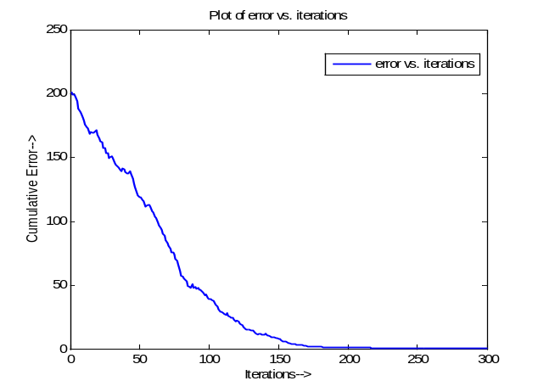
Figure 2. Cumulative error values for population size 90.

Desired Output vs. Forecasted Output
The error values corresponding to mean air temperature are shown in table 4 and are calculated using the simple formula:
Error = Desired output – Actual output.

Table 4. Hybrid technique values for temperature
Day  No. | Desired  Output | Forecasted  Output | Error  Value
1 | 17.0 | 16.3 | 0.7
2 | 20.0 | 19.6 | 0.4
3 | 16.0 | 16.2 | -0.2
4 | 21.0 | 19.9 | 1.1
5 | 22.0 | 22.7 | -0.7

The values in table 4 are represented graphically in figure 3. It shows the desired and forecasted outputs of the mean air temperature corresponding to last five days for the month of January 2009.

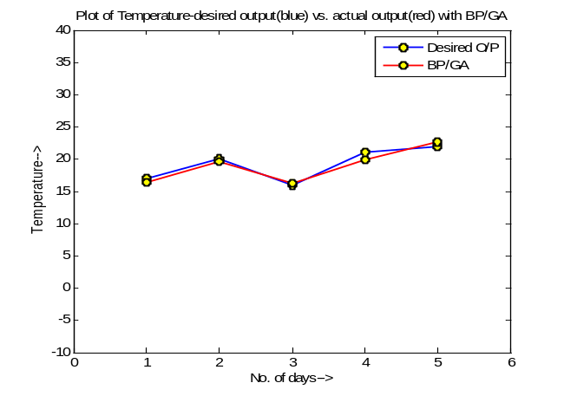
Fig. 3. 5-day-temperature prediction for hybrid technique.
The error values for daily rainfall parameter are shown in table 5 and its graphical representation is shown in figure 4.

Table 5. Hybrid technique values for rainfall.
Day  No. | Desired  Output | Forecasted  Output | Error  Value
1 | 1.9 | 2.0 | -0.1
2 | 2.1 | 2.3 | -0.2
3 | 2.3 | 2.3 | 0.0
4 | 2.5 | 2.3 | 0.2
5 | 3.0 | 2.4 | 0.6

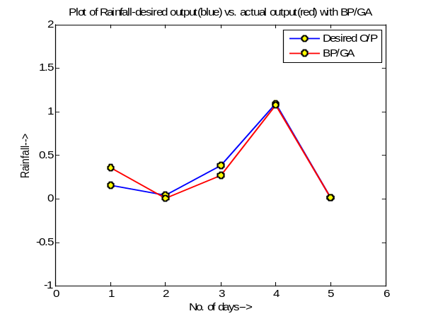
Fig. 4. Rainfall prediction for hybrid technique.
Table 6 shows the prediction of relative humidity along with the error values obtained from the subtraction of forecasted values from the desired ones and its graphical representation is given in figure 5.

Table 6. Hybrid technique values for humidity
Day  No. | Desired  Output | Forecasted  Output | Error  Value
1 | 97 | 98.9 | -1.9
2 | 98 | 98.8 | -0.8
3 | 98 | 98.8 | -0.8
4 | 99 | 99.0 | 0.0
5 | 100 | 99.0 | 1.0

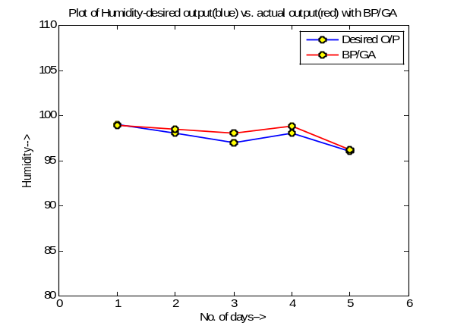
Fig. 5. Humidity prediction for hybrid technique.
The comparison of proposed integrated BP/GA technique with the traditional gradient descent based back propagation algorithm is done for the same five days data for the month of January 2009 and are shown in figure 6, 7 and 8 respectively using bar charts.

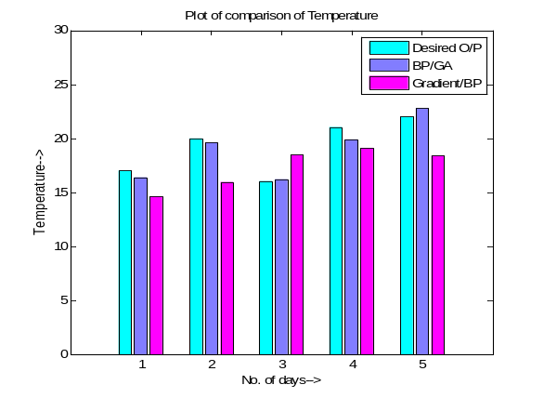
Fig. 6. Hybrid BP/GA vs. gradient/BP for temperature
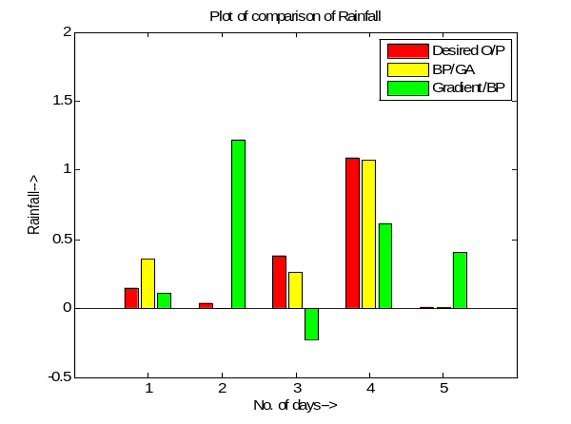
Fig. 7. Hybrid BP/GA vs. gradient/BP for rainfall
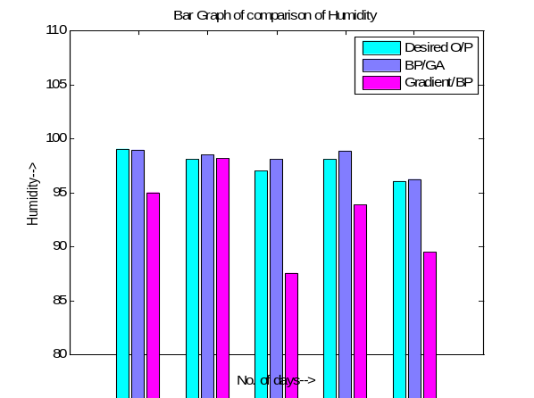 Fig. 8. Hybrid BP/GA vs. gradient/BP for humidity

The above comparison shows clearly that the integrated BP/GA technique is more suitable to predict weather than the traditional gradient based back propagation algorithm because in all the cases- mean air temperature, daily rainfall and relative humidity; the proposed BP/GA technique is more close to the desired output than the back propagation algorithm alone.

Conclusions
Meteorology is a very difficult science because of the complex and chaotic behavior of weather involved. At times these systems make forming predictions nearly impossible, as shown with some cases. However, it is shown that given the specifications of this system and the provided data, a higher accuracy rate is achieved to rival other meteorological prediction models.
The proposed technique can learn efficiently by combining the strengths of GA with BP. The proposed approach blends the merits of both deterministic gradient based algorithm BP and stochastic optimizing algorithm GA. By using local gradient information advantageously, the BP/GA is more speed efficient than GA. Hence the use of integrated BP/GA technique is proposed in weather forecasting system.

Acknowledgements
The present research would not have reached to its completion without the contribution of Prof. M. S. Seekree who enabled us to collect data regarding weather forecasting from the “Meteorological Department of Punjab Agriculture University, Ludhiana, India”.

References
- Paras et al., Feature based neural network model for weather forecasting, J. World Academy of Sci., Engg. and Tech. 34 (2007).
- A. Abraham et al., Soft computing models for short term load forecasting Hybrid Info. Sys., Advances in Soft Computing, (Physica Verlag, Germany, 2002) pp. 207-222.

- I. Maqsood, M.R. Khan and A. Abraham, Weather forecasting models using ensembles of neural networks (Univ. of Regina, Regina, Canada, 2004).

- S. Pradeepta et. al., Short term load forecasting using artificial neural network: comparison with genetic algorithm ARPN Journal of Engineering and Applied Sciences vol. 9 (2009).
- S. Caltagirone, Air temperature prediction using evolutionary artificial neural networks (Univ. of Portland, Col. of Engg. 5000 N. Willamette Blvd. Portland, 2001).
- R. Rojas, Neural networks- tbackpropagation algorithm”, (Springer-Verlag, Berlin, 1996).
- S. Rajasekaran and P. Vijayalakshmi, Neural networks, fuzzy logic and genetic algorithms (New Delhi: Prentice Hall, India, 2004).
- S. C. Ng, S. H. Leung and A. Luk, The generalized back propagation algorithm with convergence analysis (St. B&P Neural Investments Pty. Ltd., Australia, IEEE, 1999).
- Goldberg, D. E., Genetic algorithms in search, optimization and machine learning (Addison - Wesley. Reading, MA, 1989).
- I. Ioan et al., Optimization of feed-forward NN structure using GA”, Proc. Int. Conf. on Theory and App. of Maths. and Informatics (Thessaloniki, Greece, 2004).

